**DAILY ONLINE ACTIVITIES SUMMARY**

|  |  |  |  |  |  |  |  |  |
| --- | --- | --- | --- | --- | --- | --- | --- | --- |
| **Date:** | **17/06/2020** | | | | | **Name:** | **PONICA.J** | |
| **Sem & Sec** | **4TH & B** | | | | | **USN:** | **4AL18CS055** | |
| **Online Test Summary** | | | | | | | | |
| **Subject** | | **-** | | | | | | |
| **Max. Marks** | | **-** | | **Score** | | | **-** | |
| **Certification Course Summary** | | | | | | | | |
| **Course** | **WEBINAR** | | | | | | | |
| **Certificate Provider** | | | **AIET PLACEMENT** | | **Duration** | | | **2 HOURS** |
| **Coding Challenges** | | | | | | | | |
| **Problem Statement:** Write a C Program to Count numbers that don’t contain 3 | | | | | | | | |
| **Status:EXECUTED** | | | | | | | | |
| **Uploaded the report in Github** | | | | | **YES** | | | |
| **If yes Repository name** | | | | | [**https://github.com/ponica-jaya/LOCKDOWN-CODING.git**](https://github.com/ponica-jaya/LOCKDOWN-CODING.git) | | | |
| **Uploaded the report in slack** | | | | | **YES** | | | |

Online Test Details: (Attach the snapshot and briefly write the report for the same)

TODAY WE HAD NO TEST

Certification Course Details: (Attach the snapshot and briefly write the same)report for the SAME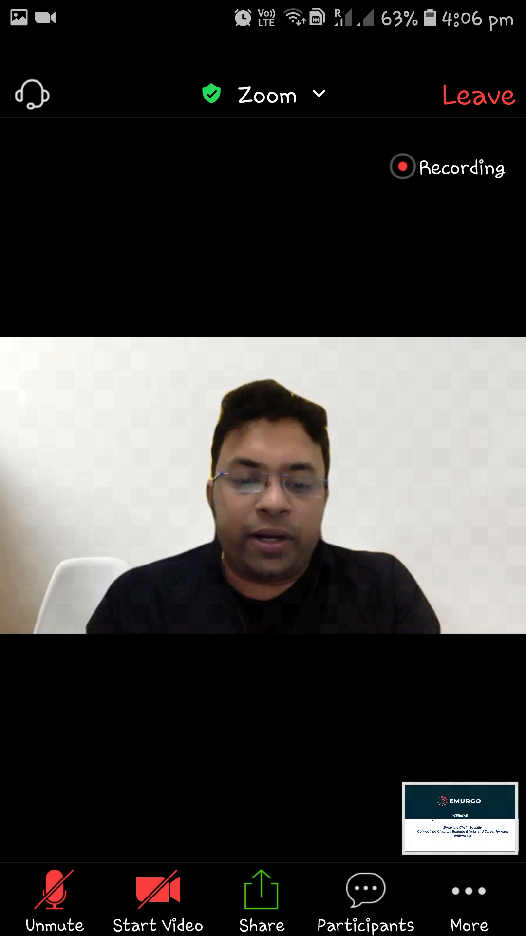

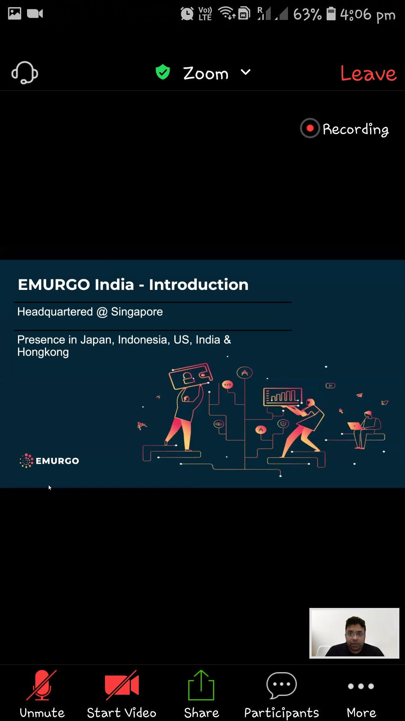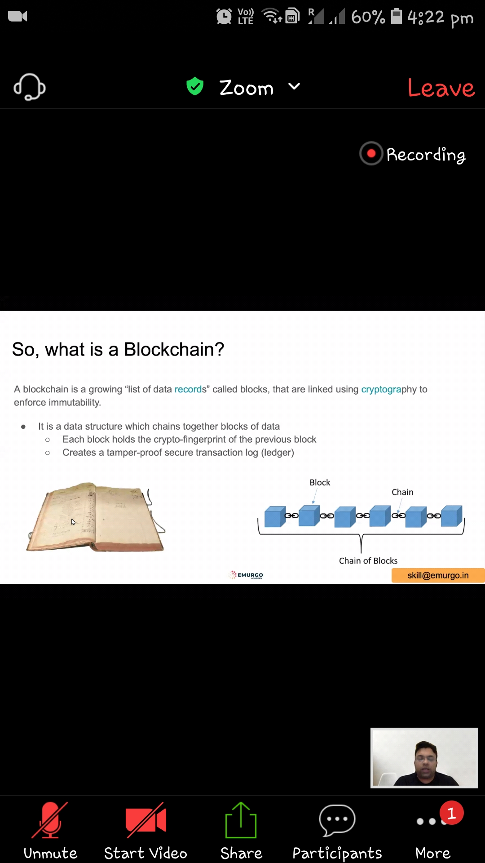

Coding Challenges Details: (Attach the snapshot and briefly write the report for the same)

TODAY I RECEIVED CODING CHALLENGE FROM MY TEACHERS AND UPLOADED IN MY GITHUB ACCOUNT

